A report on

**ON THE WAY**

Submitted by

**Dhruv Rishishwar 20BCS075**

**Sparsh Kumar 20BCS219**

**Anshul Shukla 20BCS035**

**CSE, 2021**

Submitted to

**Prof. Pritee Khanna**



PDPM INDIAN INSTITUTE OF INFORMATION TECHNOLOGY, DESIGN AND

MANUFACTURING JABALPUR, INDIA

November 16th , 2021

1. Introduction
2. Purpose & Scope
3. Users
4. Overall Description
   1. System Features and Requirements
   2. Functional Requirements
   3. External Interface Requirements
   4. Non-functional Requirements
5. Technology Used
6. Database Designing
   1. Entity Relationship Diagram (ERD)
7. Project Screenshots

**Introduction**

The name of our website is *ON THE WAY.* This project is an implementation of an online student counselling system. With this website, a student can get help from an expert counsellor from the comfort of his/her home and with absolute privacy.

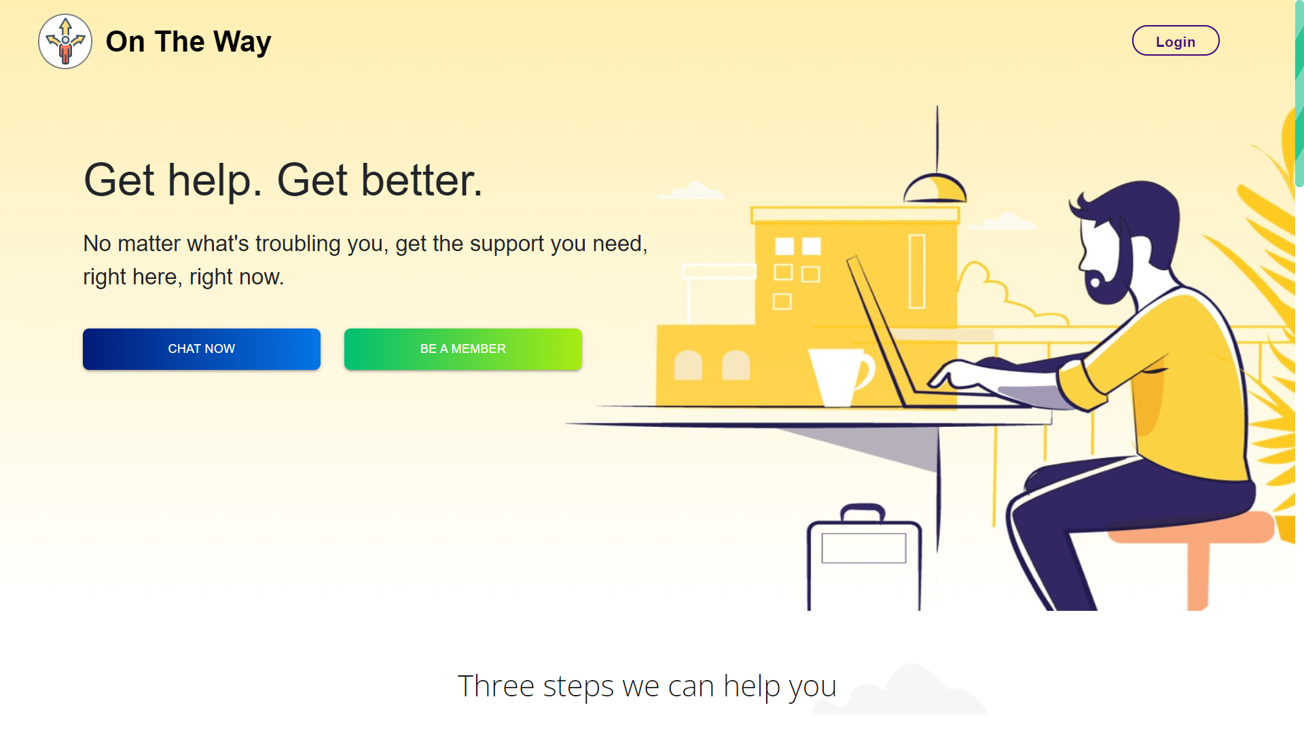

**Purpose**

The main objective of our project is to help students who are facing problems related to academics or college life like stress, peer pressure, problem in deciding their goal, poor performance in studies etc. by providing expert guidance from our counsellors.

**Scope**

The scope of this website is bound to the welfare students of IIITDM Jabalpur only. All the registered students and expert counsellors are from our college. It can provide you with personalized feedback based on a predefined quiz that a student takes and you can also chat directly with an expert.

**Users**

There are three types of users of our website :

**1. Admin :** The admin manages all activities happening on the website like :

i. Approving a newly registered counsellor.

ii. Viewing and deleting feedback, etc.

**2. Counsellor :** Counsellor is an expert who helps students in any way they need help.

**3. Student :** Students reach out to the counsellors for help.

**Overall Description**

**System Features and Requirements**

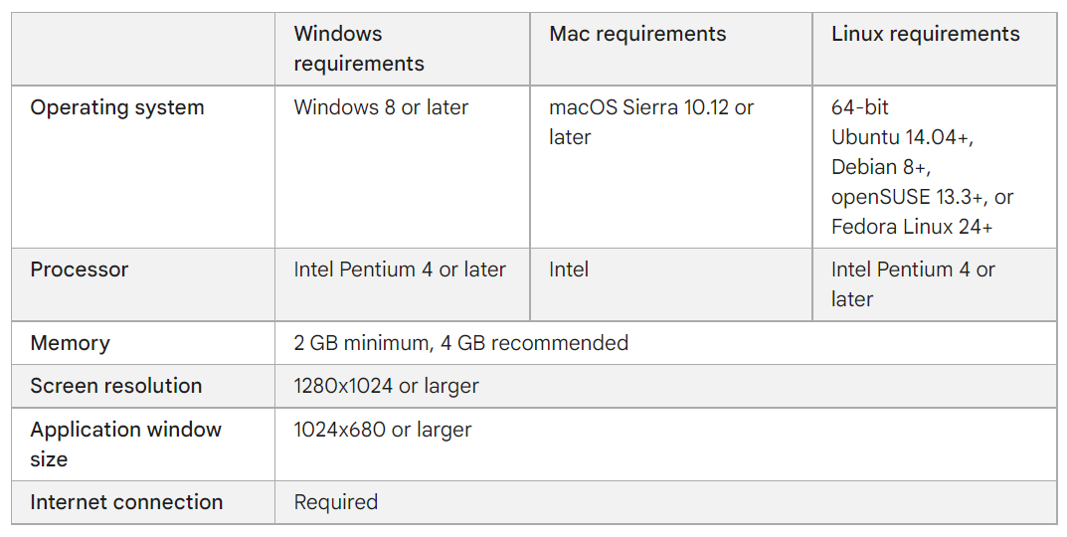

**Functional Modules**

Our project has mainly 3 modules:

1. Student Module -

* + Students can take the quiz multiple times and get personalized feedback.
  + Students can view all registered counsellors and chat directly with anyone.
  + Students have the ability to edit their profile and can give feedback regarding the website or counselling.

2. Counsellor Module -

* + Counselors can view the details of all students and chat with anyone they feel like needs help.
  + Counselors also give feedback.

3. Admin Module -

* + Admin can approve or decline a counsellor’s request to become a counsellor on their website.
  + Admin can change the questions and their options.

**External Interface Requirements**

1. A user to operate the website.
2. All the system requirements mentioned previously.
3. A web browser (eg. Google chrome, mozilla firefox, brave etc.)

**Non-Functional Requirements**

1. Performance : This is a fast website.
2. Security : It provides complete privacy.
3. Quality : It has a clean UI with good UX.

**Technology Stack**

**Frontend**

* CSS
* Javascript
* ReactJs
* HTML

**Backend**

* NodeJs
* ExpressJs

**Database**

* MySQL

**Database Designing (ER-Diagram)**

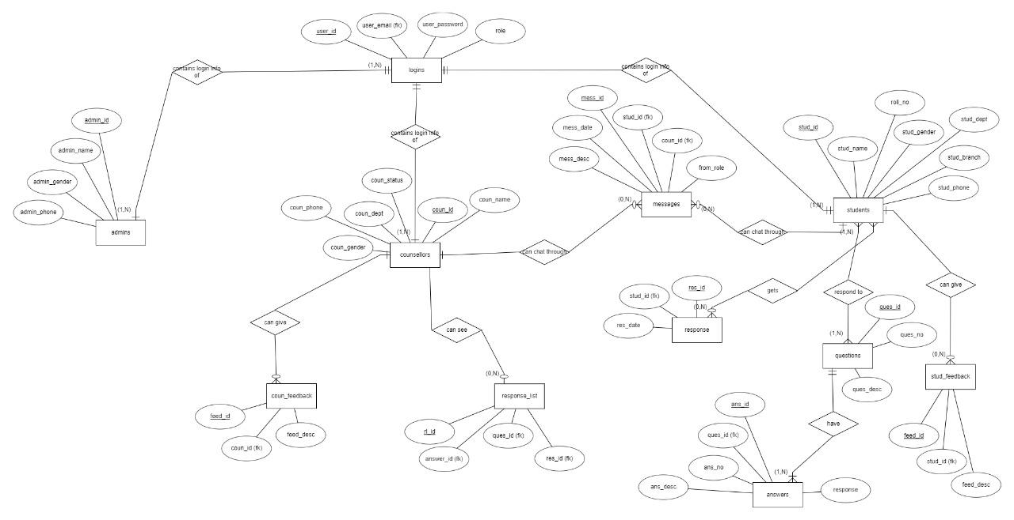

**Project Screenshots**

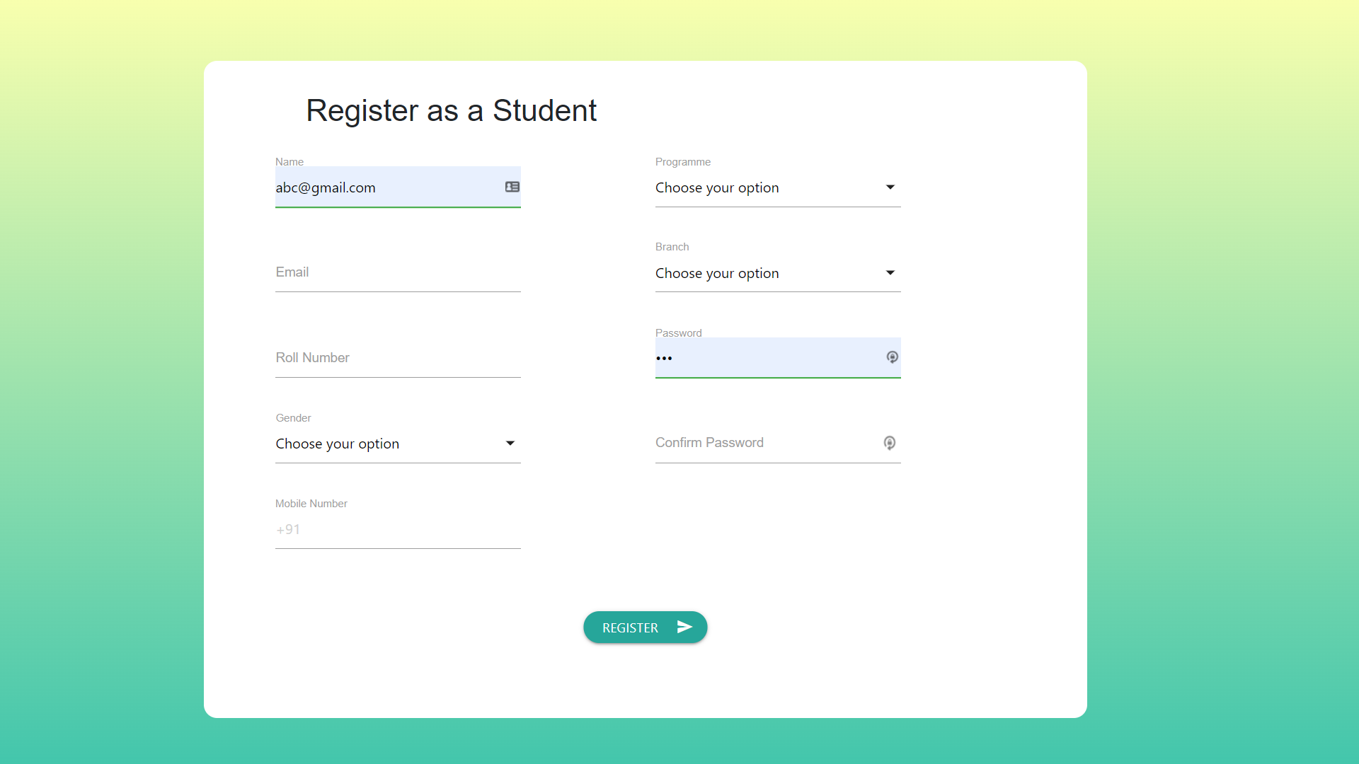

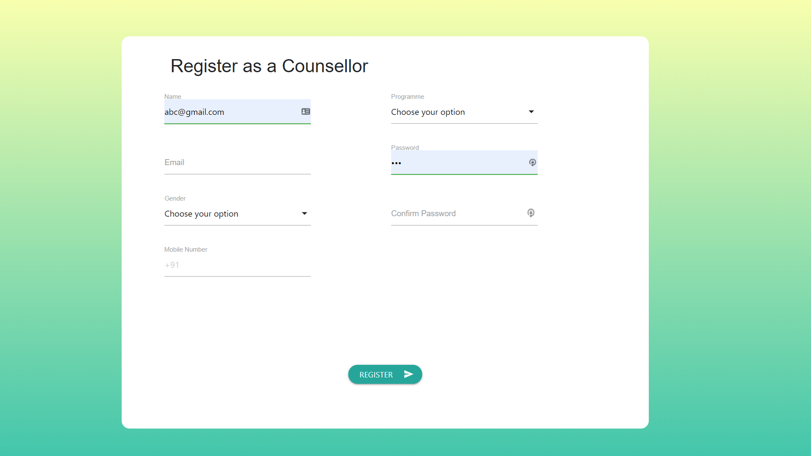

**Register as an Admin**

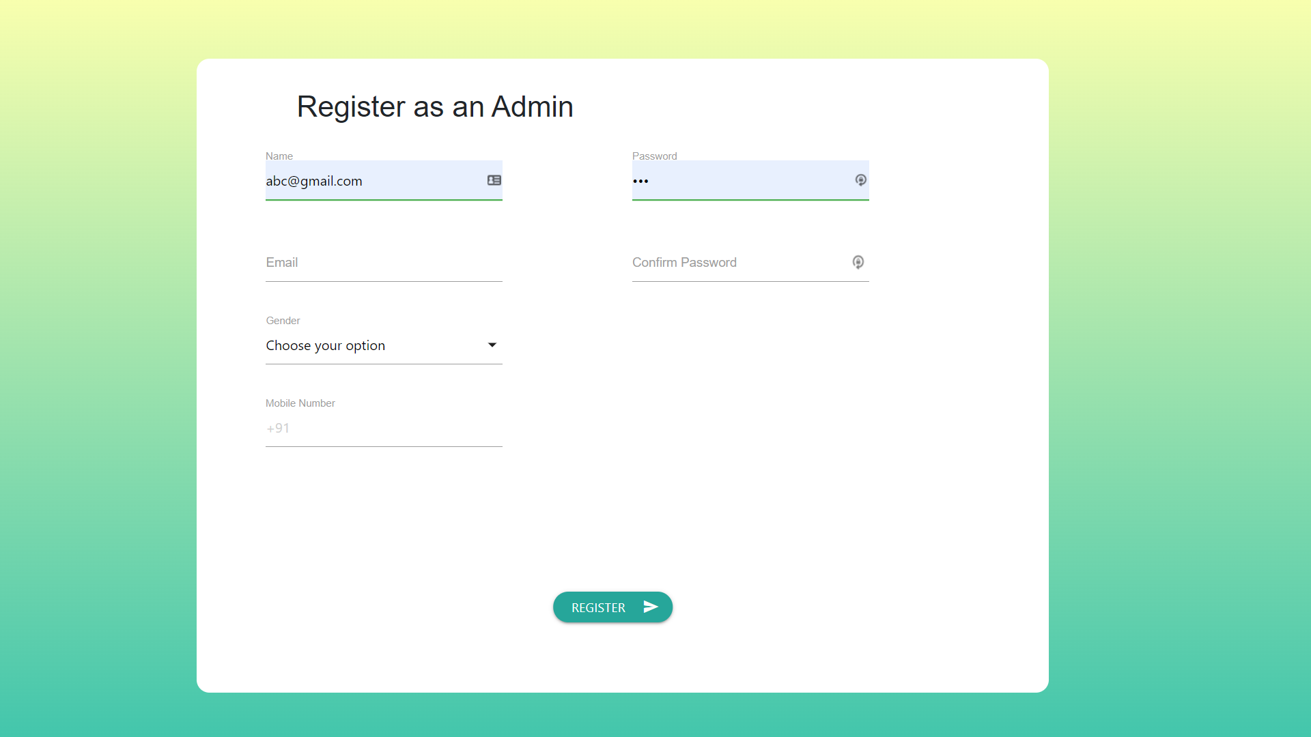

**URL -** /ad123

**Student Dashboard**

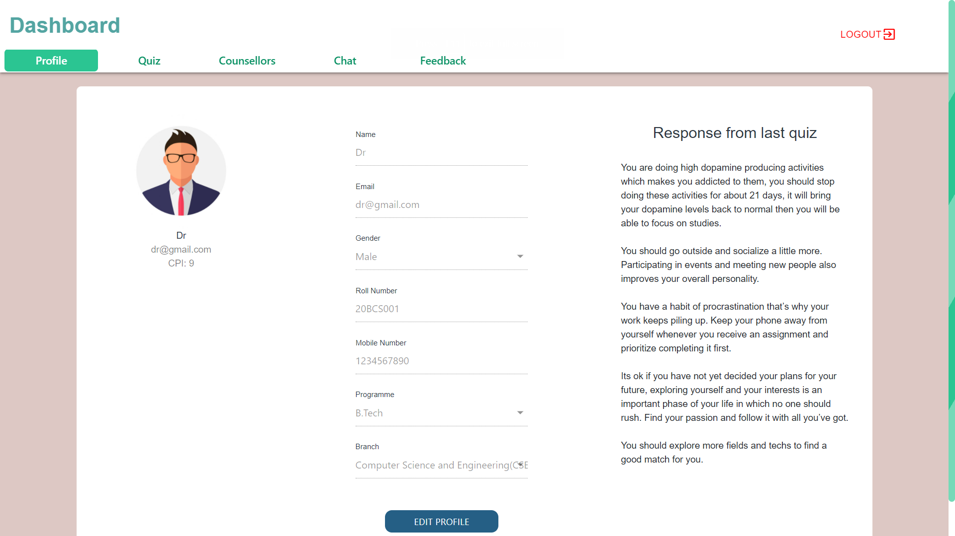

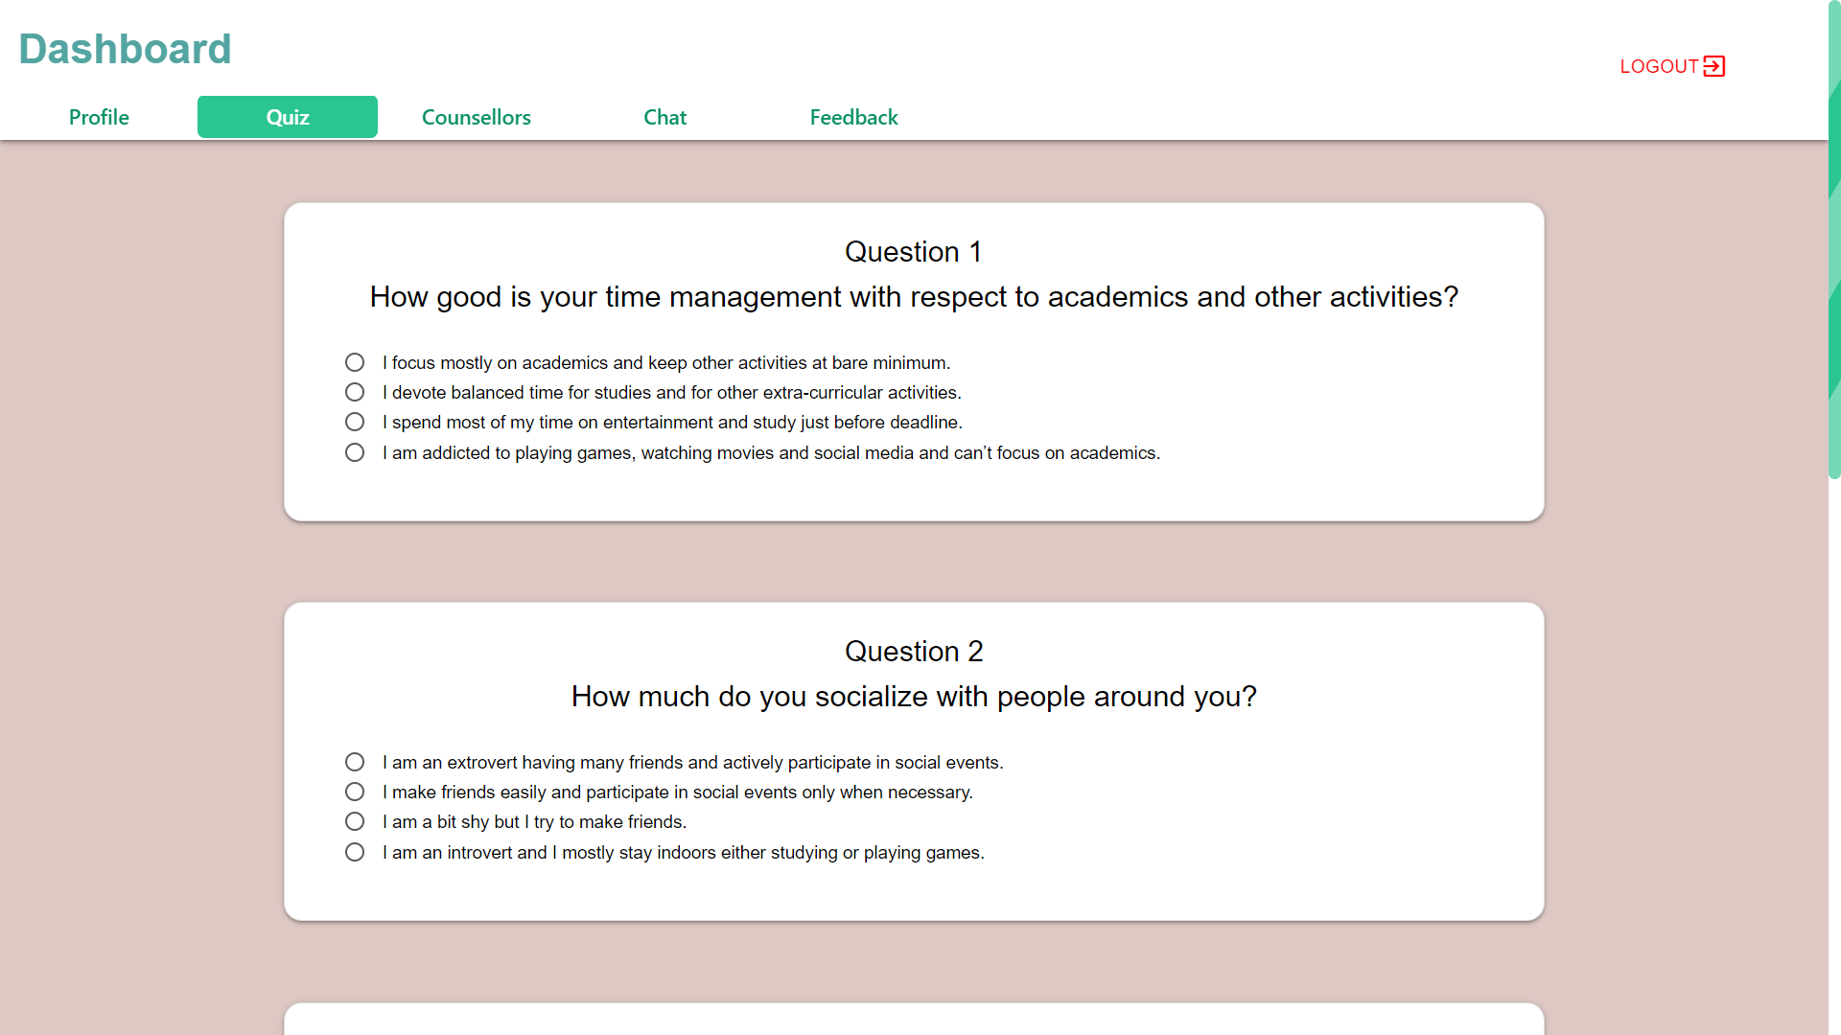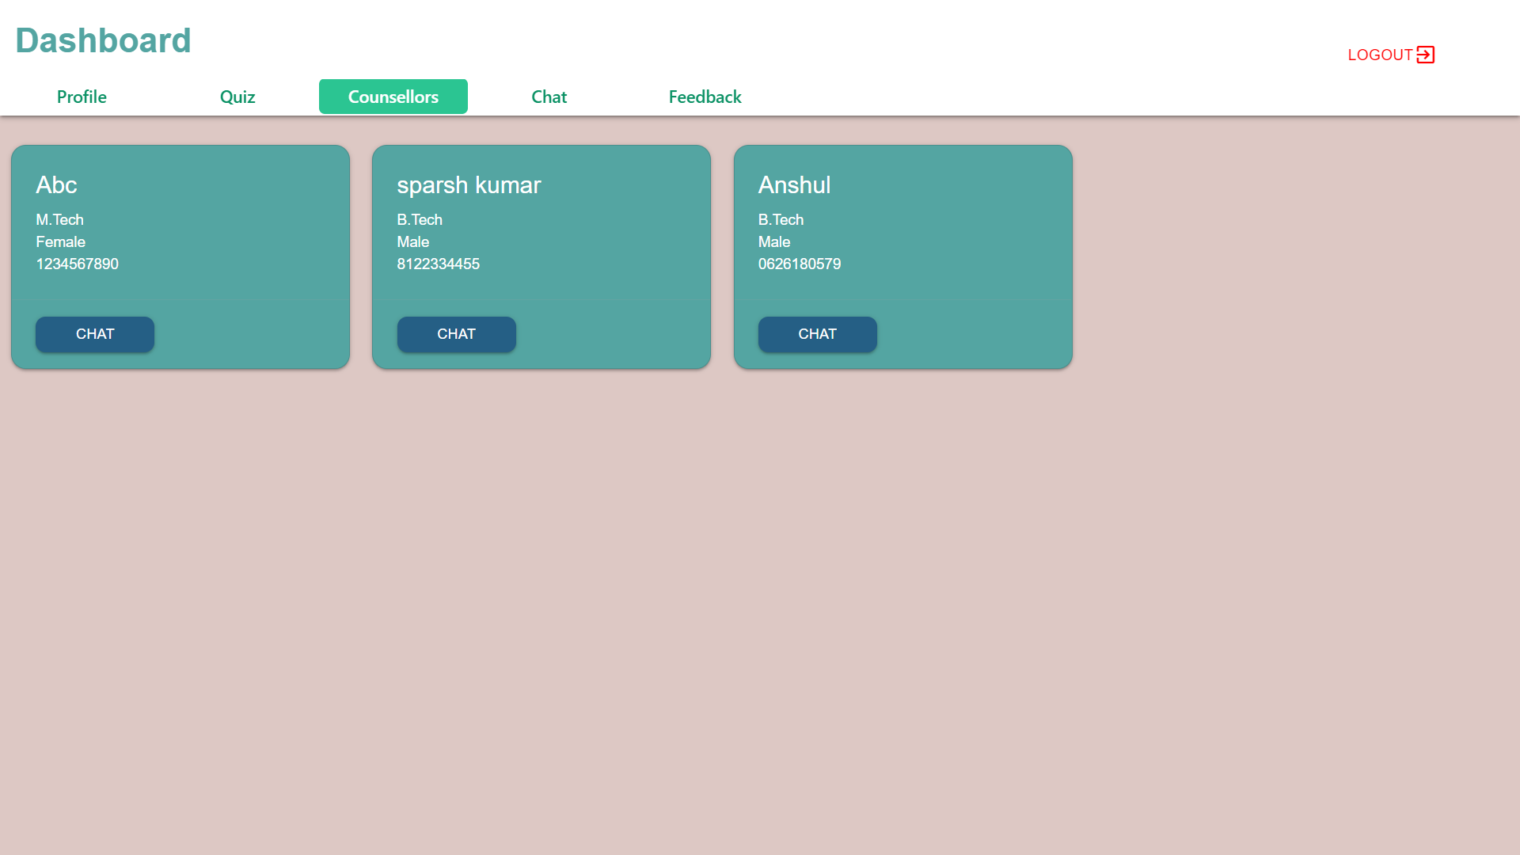

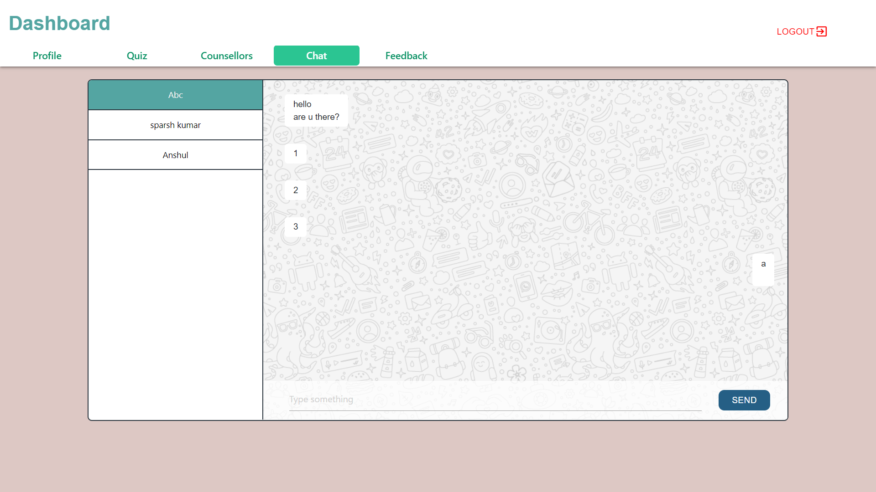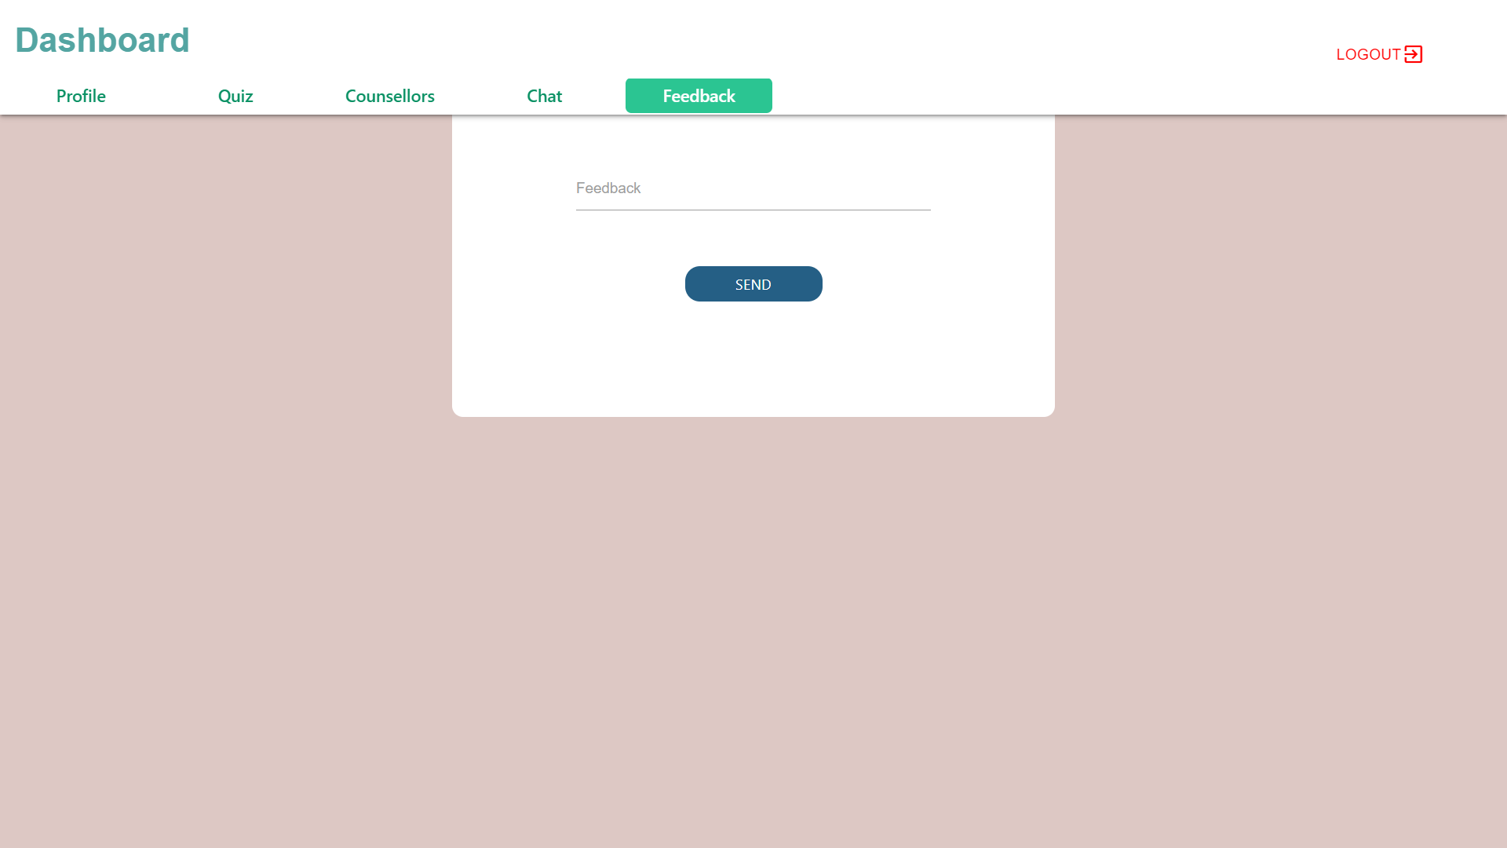

**Counsellor Dashboard**

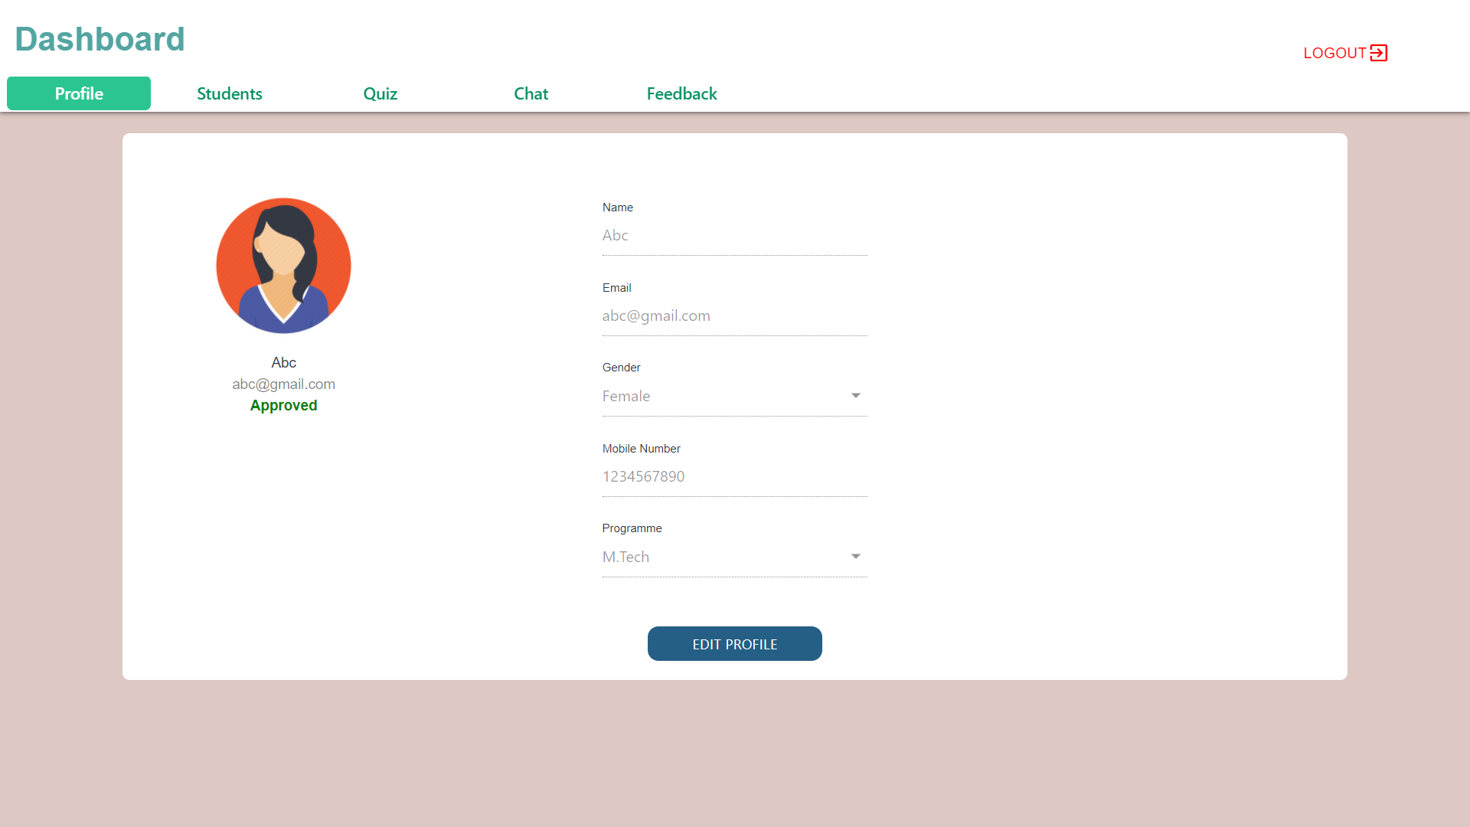

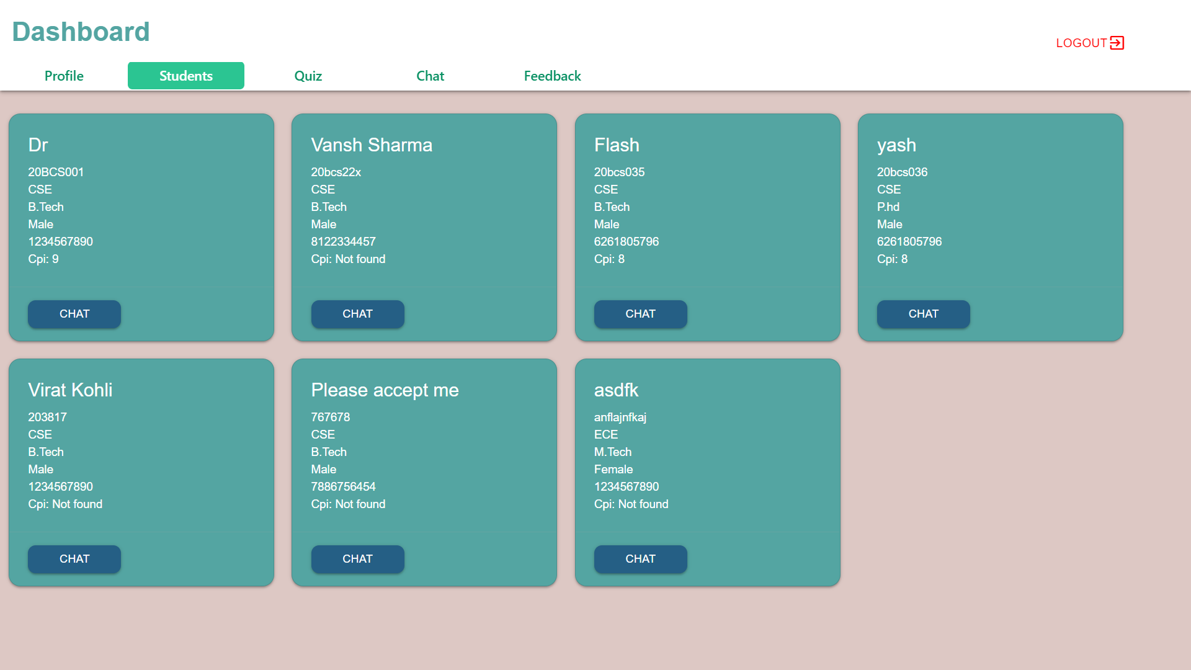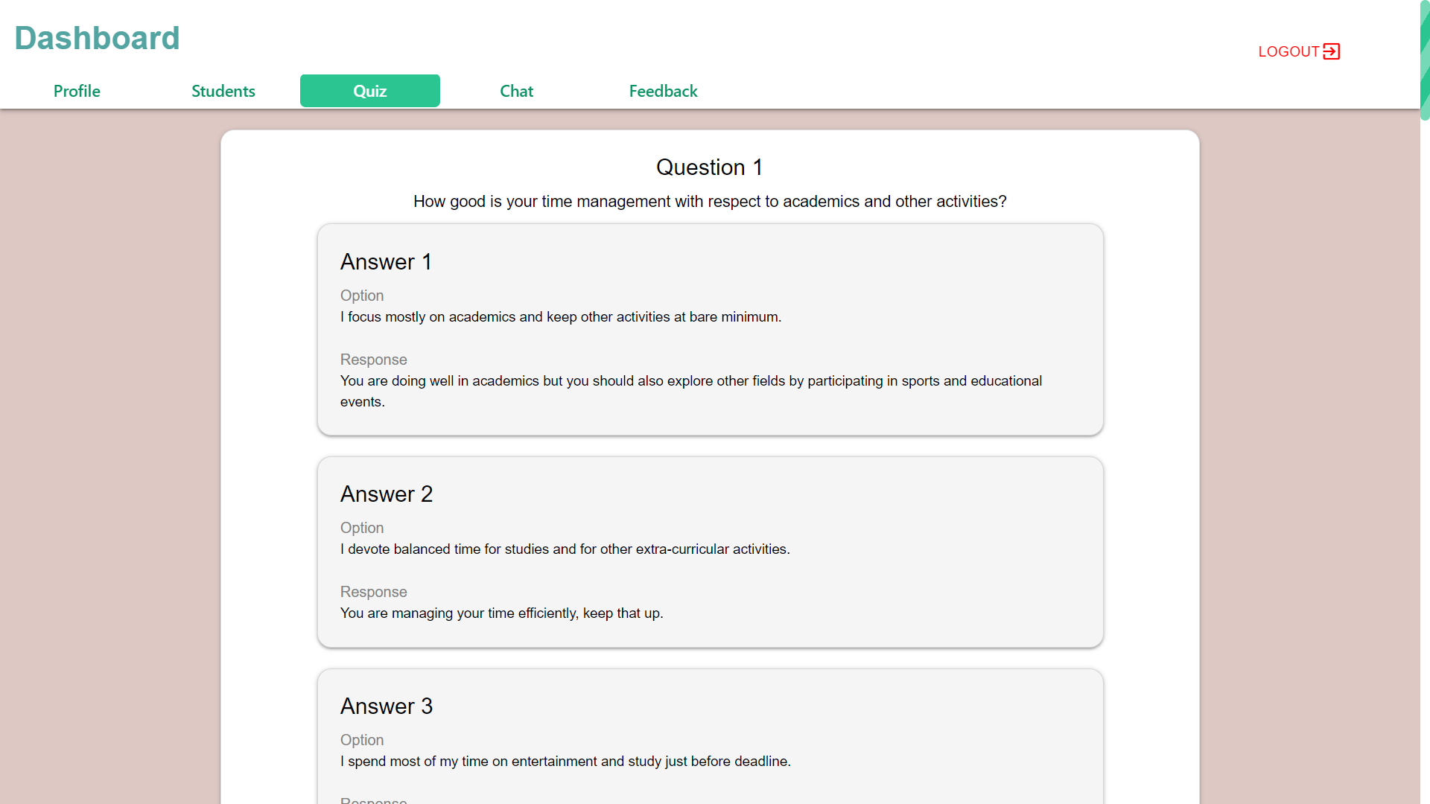

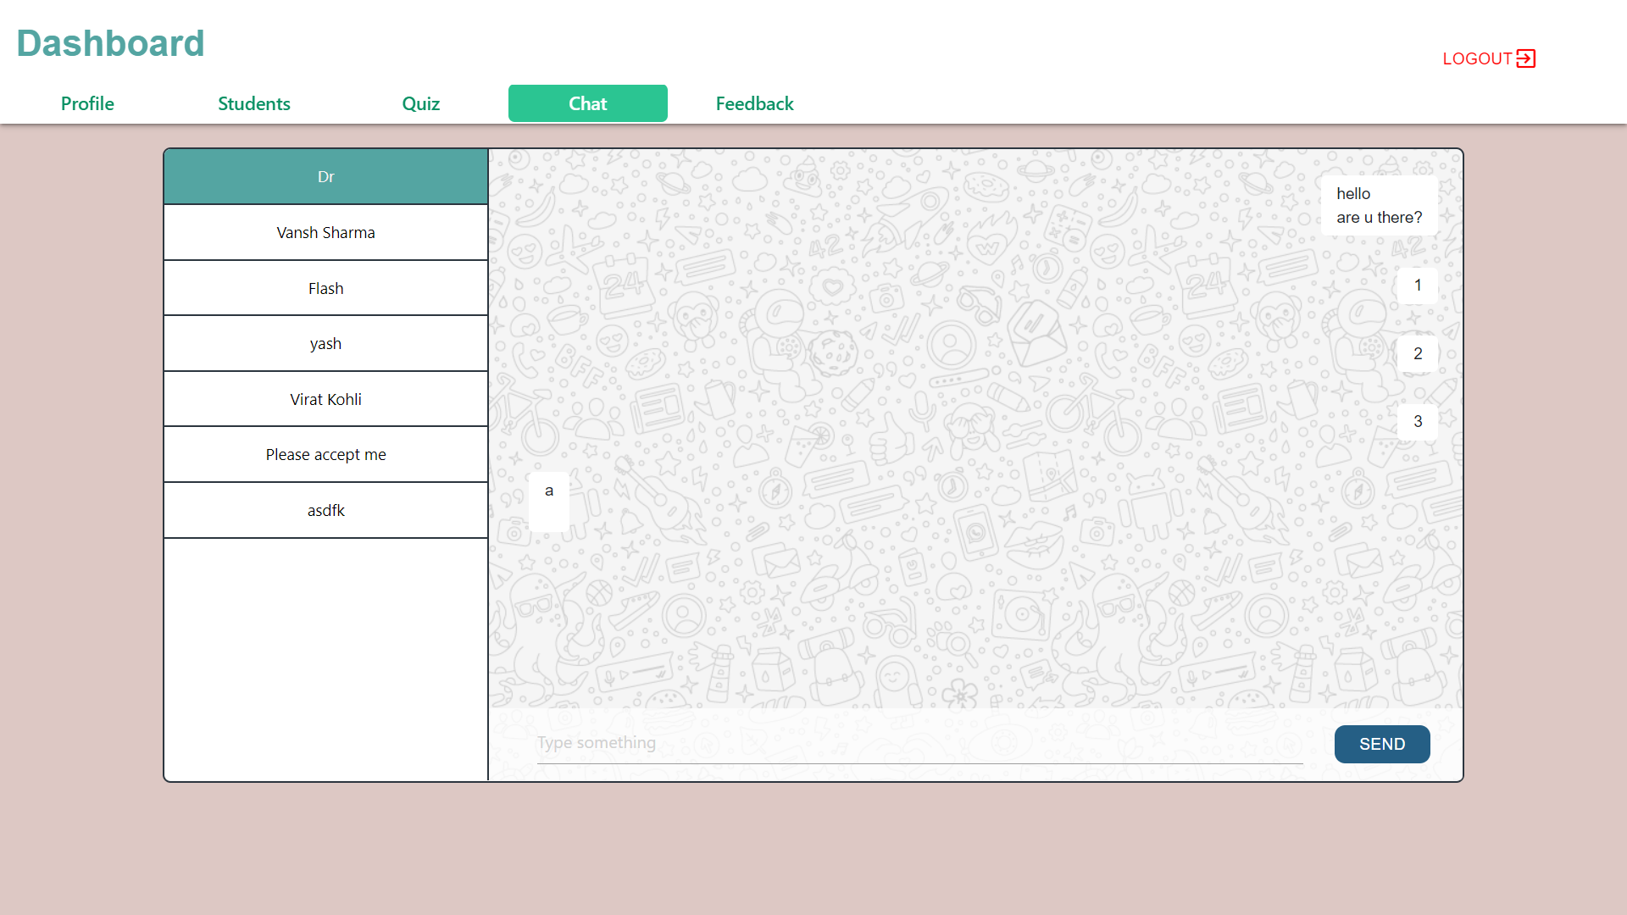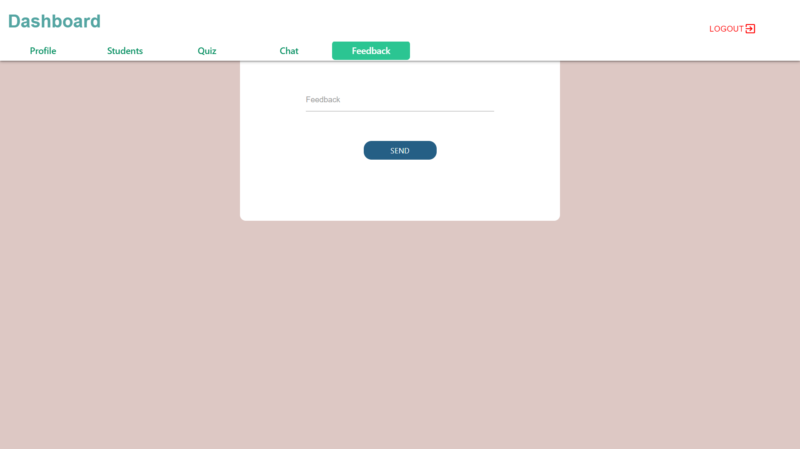

**Admin Dashboard**

